*Prison Uniforms on the Outside: Intersections with US Popular Culture*

Abstract

With the United States having the highest rate of incarceration in the world—peaking in 2008 at 755 prisoners for every 100,000 residents—it is not surprising that American popular culture is saturated with images of prison.  Although the experience of being in prison is associated with humiliation, punishment and a lack of choice (which is antithetical to the existence of fashion), numerous films, television shows, music videos, designers and retailers have demystified and even glamorized the ‘look’ of prison.  This article explores how Americans outside of prison are able to engage with this imagery—not just as passive consumers of media, but through buying and wearing prison uniform costumes, fashions inspired by prison uniforms, clothing made by prisoners and clothing formerly worn by prisoners.

Keywords

prison, inmate, uniform, film, costume, retail, fashion

Contributor details

Heather Akou is an associate professor of fashion design and director of the Elizabeth Sage Historic Costume Collection at Indiana University. Her research focuses on African dress and fashion, contemporary Islamic fashion, aesthetics, politics, embodied religious practices, and representations of non-Western dress and fashion in scholarship and museum collections.

*Prison Uniforms on the Outside: Intersections with US Popular Culture*

*In 1966, Andy Dufresne escaped from Shawshank prison. All they found of him was a muddy set of prison clothes, a bar of soap, and an old rock hammer, damn near worn down to the nub.*

* Morgan Freeman narrating as ‘Red,’ *The Shawshank Redemption* (1994)

In the introduction to his seminal book, *Discipline and Punish* (*Surveiller et Punir*), Foucault describes two very different methods of handling prisoners: a gruesome public execution carried out in 1757, contrasted with a timetable developed eight years later for reforming prisoners in a silent, monastery- or factory-like setting (1975). As the work of government in Europe and North America gradually became more impersonal and bureaucratic, punishment became less of a public spectacle—serving as a warning to other would-be criminals—and more of a shamefully-private experience inside prisons, intended (at best) to reform the prisoner or (at worst) to destroy the prisoner’s mind and soul.

At first, prisoners wore their own clothing, regardless of their length of sentence or the condition of their clothing upon arrival (Ash 2009). Wardens were often unwilling or unable to pay for additional clothing; however, activists argued that adequate clothing was crucial for the health and morale of prisoners, who would otherwise be morally indecent, filthy, and freezing in the winter. Elizabeth Fry, a Quaker activist in the early nineteenth century, worked to raise awareness of conditions at London’s Newgate Prison (where she observed prisoners removing clothes from a dead child in order to dress another imprisoned child), convincing the public to make donations of ‘clothes for the women, clean straw for bedding, and sewing materials to make clothing’ (Craig 2006: 142). By the end of the century, dedicated prison uniforms were becoming the norm (Ash 2009: 29), viewed as being necessary for segregating the prisoners, establishing control (even to the point of humiliation) and for making them easy to identify in the event of an escape. While prisons in the UK adopted a ‘broad arrow’ insignia for prison uniforms (Ash 2011)—a mark of being government property—stripes were common in other parts of Europe and North America. For centuries in Europe, stripes had been viewed as the ‘devil’s cloth,’ associated with Jews, jesters, clowns, and prostitutes (Pastoureau 2001: 2). In some parts of the United States, prison uniforms with horizontal black-and-white stripes persisted well into the twentieth century and have begun to reappear—most infamously, in Maricopa County, Arizona, where sheriff and politician, Joe Arpaio, was in charge of the prison system from 1993 to 2017 (Chairez 2017).

For humanitarian reasons, prisons in Europe have largely returned to the practice of letting prisoners wear their own street clothing instead of uniforms, a subject discussed at length in *Dress Behind Bars* by Juliet Ash (2009). Prisons in the United States, on the other hand, have shifted to a diverse array of jumpsuits, scrubs, fatigues and denim, with different levels of government (county, state and federal) making their own rules—sometimes, but not always, by copying other prisons. The state of Indiana, for example, uses jumpsuits for men and two-piece scrubs for women. These uniforms are color-coded: orange for prisoners who are new or being transported, red for high-risk prisoners in segregation, green for work crews inside the prison, yellow for work crews outside of the prison and khaki for general population (PEN Industries 2018). Prisoners appearing in court are required to wear orange (the color of transport), which makes them highly visible. Prisoners in the city of New York are allowed to wear their own clothing and accessories in court (Durkin 2016), however there are numerous restrictions on the value, materials, style and color. For example, a guide for family members sending clothing to prisoners sets the following limits on footwear:

No hollow or platform heels or soles. No camouflage design. No metal shanks/ supports or toes. No pointed toes, spiked heels, pockets, compartments, clog-type or pump (air-inflation) footwear. No metal/stone or clip-on decorations. Max. height of heels: males 2"; females 3". Measure boot height from bottom of heel. Size must be within 1 size of that being worn by offender.

The value of the footwear cannot be greater than 50 USD. Although color combinations are allowed (unlike clothing, which must be a solid color), the colors cannot include blue, black, gray, or orange. Baseball caps cannot be ‘military style’ or have a logo. Rain jackets must be clear and handkerchiefs can only be white. Rosaries (used by some Catholics, Muslims, and Buddhists) can only have black beads (New York State 2018).

Although contemporary media images like *Orange is the New Black* (2013-present), the music video for ‘Heathens’ by Twenty-One Pilots (2016), and a clip at the end of *Venom* (2018) (with actor Woody Harrelson as the villain ‘Carnage’) often depict ‘prisoners’ wearing orange jumpsuits—similar to real-life images of prisoners of war at Guantanamo Bay (Ash 2009)—this style of uniform is far from being universal in the United States. For example, the company Levi Strauss (better known as a manufacturer and seller of blue jeans) was a major supplier of denim to US prisons throughout the twentieth century (Panek 2016).

Worldwide, there has been very little academic research about prison uniforms; this article is the first to focus specifically on the United States. Although there has been some research about other types of uniforms—for example, military uniforms (Laver 1948, Elting 1988), occupational uniforms (Bates 2012, Crane 2012), school uniforms (Craik 2005, McVeigh 2000), and sports uniforms (Marion 2008, Pickhartz 2011)—prison uniforms have some unique features. While they deny opportunities for self-expression (much like occupational uniforms) and convey the ideology of the government (much like military uniforms), prison uniforms are not intended to instill a sense of pride, professionalism or teamwork. They reduce markers of social class (like school uniforms), but they are often designed to be humiliating and punitive—in effect, one of the ultimate examples of anti-fashion. By offering a broad overview of how prison uniforms in the United States are manufactured, sold, and portrayed (even glamorized) in popular culture, this article aims to inspire further research about this neglected topic.

**Prison Uniforms in Films and Television**

For decades, the United States has had one of the highest rates of incarceration in the world, peaking in 2008 at 755 prisoners per 100,000 residents (Jacobson, Heard and Fair 2017: 1). Although China, for example, also has a high rate of imprisonment and more than four times the population of the US—1.39 billion residents compared to 331 million (census.gov 2019)—the number of prisoners is roughly equal, around 2.1 million people (World Prison Brief 2019).[1] Some segments of the US population have far more experience with prisons than others. At the time of the 2000 US Census, for example, more than ten percent of all black men in their twenties to early thirties were recorded as prisoners (Jacobson, Heard and Fair 2017: 12).

As observed by Joshua Price in *Prison and Social Death* (2015), the experience of being in prison is dominated by frequent humiliation.

In prisons and jails, the state through its agents, practices, and policies exercises its power to humiliate. When people are incarcerated, they are forced to depend on the institution for their well-being. […] Humiliation in prison is not merely pervasive; it is organized, institutionalized, routine, and largely legal… (42)

Despite decades of activism to make the experience of prison more about rehabilitation than humiliation, the idea that prison should be a hidden, shameful experience is widespread. On the website for the Indiana Department of Corrections, for example, a list of frequently-asked questions includes, ‘If people are sent to prison for punishment, why should they be allowed televisions, radios, free education and access to gymnasiums, and libraries, as well as medical and dental care?’ The state responds that ‘idle prisoners would require more supervision,’ but also that the penal code is based on reformation and not ‘vindictive justice’ (2018).

Regardless of this underlying tone of shamefulness, American popular culture is loaded with images of prisons and prisoners. Dozens of prisons from the eighteenth and nineteenth century have been turned into museums, including Alcatraz, Ohio State Reformatory (where most of *The Shawshank Redemption* was filmed), Joliet Correctional Center (used to film the opening scene of *Blues Brothers* while it was still operating)and Louisiana State Penitentiary (more commonly known as Angola State Prison or ‘the Farm,’ shown in *Dead Man Walking*). Kevin Kehrwald, author of *Prison Movies: Cinema Behind Bars* observed that,

Although this book focuses primarily on prison *ﬁlms*, it’s worth noting the sheer volume of prison-based narratives recently created and currently being produced as television series, documentaries and reality shows. The HBO drama *Oz*, for example, ran for six seasons, from 1997 to 2003, producing 56 episodes. The Netﬂix series *Orange is the New Black* is, at the time of writing, in its fourth season, having garnered a great deal of popular success and critical acclaim. The FOX drama *Prison Break* ran for four seasons, from 2005 to 2009 […] The 24-hour news channel MSNBC frequently runs lengthy weekend marathons of *Lockup*, a reality show/documentary series that proﬁles guards and inmates at various penal institutions around the United States, to date having produced over 230 hour-long episodes. *Lockup* also spawned the spin-offs *Lockup: Raw*, *Lockup: Extended Stay* and *Lockup: World Tour*. (2017: 4).

While these productions range from documentaries (i.e. *The Farm: Angola, USA*) to entirely fictional stories (i.e. *Cool Hand Luke*), their depictions of uniforms worn in prisons are often highly accurate. Many fall into one of three categories (see Table 1): black-and-white stripes; denim, chambray, and t-shirts; or jumpsuits and scrubs.

The comedy film *Cookie’s Fortune* (1999), for example, was set and filmed in the small town of Holly Springs, a real town located in Marshall County, Mississippi. During the scenes where Camille Dixon (played by Glenn Close) is incarcerated for the murder of her aunt, she wears an orange jumpsuit with ‘Marshall County Jail’ printed on the back. Inspection of the costume (figures 1, 2, and 3) reveals that the jumpsuit is an authentic prison uniform made by Bob Barker,[2] a major supplier of uniforms and other products used in prisons in the United States (Bob Barker 2018). Although these scenes were brief in the film, the uniform—a size large, made from a blend of polyester and cotton—shows heavy use including two cigarette burns.[3] The uniform was likely worn by actual prisoners in Marshall County prior to the film, then purchased or donated for the actress to use as a costume.

In contrast, the ‘chain gang’ uniforms for *O Brother Where Art Thou?* (2000) were made specifically for the film (figures 4 and 5). After the grey-and-white striped fabric was sewn into garments (using sewing machines for basic construction and hand sewing for the details, such as pockets and buttonholes) the uniforms were stained and distressed to simulate heavy wear at the elbows and knees, seams, and hemlines (which, in real life, would have been added and ‘let out’ several times on the uniforms to accommodate different body sizes). While this film is also a comedy, building on the story of *Iliad and the Odyssey*, it accurately depicts many aspects of ‘chain gangs’ in the southern United States in the 1930s including the uniforms (see figure 6). For the opening scene where the prisoners are singing “Poor Lazarus,” directors Joel and Ethan Coen used a field recording of an authentic chain gang song made by folklorist Alan Lomax in Parchman Farm, Mississippi in 1959 (Association for Cultural Equity 2018).

**Prison Uniforms Outside of the Prison**

Surprisingly—given the high rates of incarceration in the United States and impact on American culture—there does not seem to be much prison clothing in museums. While the Smithsonian has thousands of artifacts—mostly documents and photographs—related to prison life, it only has four sets of clothing: eight hoods worn by prisoners arrested for conspiring to assassinate President Lincoln (COLL.CONHDS.005001), ‘pajamas’ worn by a pilot held as a prisoner of war at the infamous ‘Hanoi Hilton’ (2004.0083.02), an outfit worn by Albert Woodfox at the time of his release from Angola State Prison in 2016 after 43 years in solitary confinement (2017.34.1-.2), and several pieces of clothing worn by Wilbert Rideau, who was held for twelve years on death row at Angola (item 2016.139.7, for example, is a blue denim jacket). The Costume Institute at the Metropolitan Museum of Art—one of the largest collections of clothing in the world—has only one pair of shoes worn by a former prisoner during the US Civil War, who walked home in leather brogans (2009.300.3495a, b). When I contacted the Chicago Historical Society—a social history museum with an equally-large collection of clothing—a collection manager informed me that there was nothing available related to prisons, and that ‘knowing the past curators of this collection I seriously doubt we have ever collected any of that material here’ (Pushor 2018). In an article for the *Journal of Design History*, fashion historian Juliet Ash observed a similar lack of interest in studying and collecting prison uniforms in the UK (2011).

Although one might assume that prisoners are not allowed to keep their uniforms at the time of release (or would not want to, given their symbolism), in parts of the United States this is not always the case. As the writer for a *New York Times* article on ‘jailhouse chic’ observed, ‘Well before the Gap reinstated khakis [a mainstream fashion in the late 1990s], they were the uniform of Los Angeles’s Chicano gangs, who wore their jail issued trousers as a badge of pride’ (2000: 8B). While eBay’s policy on ‘police-related items’ officially prohibits sellers from listing ‘authentic prison uniforms,’ (2018) some slip through, disguised as ‘costumes’ or simply ‘pre-owned’ clothing. For example, in a listing for a pair of ‘house shoes’ touted as being from the Los Angeles County Jail, the seller advertised:

(Ebay policy prohibits the sale of current prison clothing. Only clothes no longer used and over 20 years old can be sold.) This pair of shoes meets both requirements and remain in great condition. Clear readable LA County embossed on item. Rare white color slip on "Vans" style. The white color are a hot item.  Since these white shoes are no longer issued to regular inmates only the bosses and jail shot callers get to wear them making this a sought after item in jail. Now here is a fresh pair available...once these are gone they are gone! The only way to get another pair will be to; Get arrested; fight your way to the top of the jailhouse inmate structure; and become a boss... or you can skip all that and own these. (needfulthingsvintage 2018)

Another seller offered an elaborate reason for selling ‘Authentic California State Prison denim jeans,’ which he had purchased in bulk from the state of California to use for ‘changing the oil in my car’ (papershuffler 2018).

Up for auction are several pairs of authentic (and, let’s face it, *ugly*) California State Prison denim jeans. These were not only *issued* to prisoners in California State Prisons as official prisoner garb, but they were *made* by those prisoners in the prison industrial shops. They are tagged as PIA (or Prison Industry Authority, the California state agency that manages prison labor and industry). So, they’re American made! […] Are these *attractive* or *stylish* jeans, you might ask? No. No, they most certainly are not. (Well, to each his own of course—perhaps you might find these visually appealing, but I sure don’t.) I’m certainly no fashion expert, but I believe the technical term used for this style in the fashion industry would be ‘ugly.’

Manufacturing is widespread in many state and federal prisons. Some of the most common products made by inmates include license plates (Park 2017), traffic signs, cleaning supplies (Dettro 2015), furniture (Hawkins 2017) and clothing. While the practice of employing inmates is highly controversial—described by some journalists and politicians as ‘job training’ that gives prisoners something to do while making them more employable after release and by others as a contemporary form of slavery (Hardy 2017, Corbett 2018)—in many cases, the products are quietly made available to organizations and individuals outside of the system. In the state of New Mexico, for example, the homepage for ‘Corrections Industries’ advertises,

State, City, County, Tribal, Federal, Education and Not-For-Profit agencies can purchase directly from us without the need of a competitive bid. Our one stop shopping can fill all your [needs for] furniture, moving, printing and janitorial supplies as well as custom designed shirts and uniforms. Our friendly sales staff is available for free consultations on any of the products or services we offer. (2018)

The Commonwealth of Virginia requires all agencies ‘supported in whole or in part with state funds’ to make purchases from Virginia Correctional Enterprises. It also allows purchases by ‘any county, district of any county, city or town and by any nonprofit organization, including volunteer livesaving or first aid crews, rescue squads, fire departments, sheltered workshops and community service organizations.’ (‘Procurement Manual’ 2018). Some of the clothing, such as belts (114), khakis (117) and work boots (119) could easily be used outside of prisons, but others such as caps with the ‘Virginia Corrections’ logo (114), jumpsuits (116) and button-down shirts for officers (118) are clearly meant for official use only (‘Digital Brochure’ 2018).

Uniforms for the state of Oregon prison system are also made by prisoners. At a facility established in 1989 at Eastern Oregon Correctional Institute in the town of Pendleton (which is better known for Pendleton Woolen Mills), selected prisoners make ‘blue jeans, jackets, work shirts, sweatshirts, T-shirts, hats and more’ for wholesale to state agencies and non-profits, but also for public retail (Correction Connection 2018). Most clothing sold to the public under the ‘Prison Blues’ label (‘Made on the INSIDE to be worn on the OUTSIDE’) is affordable and heavy-duty, appropriate for industries such as farming and construction. While fashion markets are not the goal, from time to time the label has become popular. A spread in the *New York Times Magazine* in 1995, for example, noted, ‘These boys don’t just look bad. They’re all convicted criminals in the Oregon prison system. And the clothes they’re wearing are made by inmates (including the models themselves) for the Prison Blues clothing label.’

Five years later, a senior editor for *The Source* (an online, hip-hop magazine) observed a recurring appeal for urban street fashions, including prison uniforms: ‘Fashion is always coming back to the boulevard for inspiration… This time around, it's getting a little grittier and taking it to the prison yard.’

It will come as a surprise to many, no doubt, that the prison yard could have connotations of glamour. For that matter, it would have been hard to foresee a vogue for "wife beaters," as Stanley Kowalski-style tank tops are called on the street, worn both as shirts and head scarfs; for Hanes T-shirts as must-haves; or for tight nylon do-rags and bandannas manufactured even by Tommy Hilfiger, the mass-market designer, who jumped the trend by introducing a line of logo skullcaps two years back. "The prison look is a backlash against these urban labels," said Kevin Burrus, a New Jersey-based party promoter who dresses "thug style," as he stood on 125th Street last week. "Back in the day, Gucci and Calvin Klein were what it was all about. You had status on your behind. Now, it's Sean Puffy Combs charging you $75 for a pair of jeans. And I say to the label freaks: 'Those people whose names you're wearing have pool filters. You understand? And you don't even have a pool!' So when you put on the headpiece, the handkerchief, the do-rag, it's a look that's defying all that." (Trebay 2000)

Despite the anti-fashion, anti-capitalist symbolism of prison uniforms, several mainstream fashion designers have created lines of clothing inspired by ‘cellblock chic,’ including Bob Mackie, Mary McFadden, Marc Bower, Anne Bowen, Betsey Johnson, and Sylvia Heisel (New York Times Magazine 1999). More recently, FIT graduate Shayne Oliver developed a line of prison-inspired clothing for his private label, ‘Hood by Air,’ which was shown at New York Fashion Week (Euse and Cooper 2015).

Nearly thirty years after operations began, Prison Blues clothing can still be purchased through a variety of retailers including David Morgan, Logging Supply, Bailey’s (specializing in ‘professional outdoor work gear and equipment’) and All American Store (‘Building America One Purchase at a Time’). Some of the clothing has even been exported as fashion to Italy, Germany, and Japan (Erlich 1994, Goldfield 2001). With the state of Oregon prison system functioning as a steady buyer, the company is somewhat insulated from the financial risks of manufacturing fashion. Judging from a Prison Blues ‘yard coat’ that I purchased via Correction Connection (figure 7), the clothing is well-made and highly durable; for example, the buttons are solid steel, stamped with the Prison Blues logo (figure 8). It is certainly not ‘fast fashion.’ Other mainstream clothing brands commonly worn by prisoners, such as Fruit-of-the-Loom (underwear and t-shirts), Russell Athletics (fleece), Gildan Activewear (fleece), KC Caps (hats), Williamson-Dickie (pants) and Levi Strauss (denim)[4] are also widely available on the outside. While the brands are familiar to former prisoners, their use in prisons is not widely advertised; outsiders are unlikely to view them as being connected with prisons.

**Performing Prison through Costumes**

Unsurprisingly, retail websites like eBay, Amazon, and halloweencostumes.com have many examples of ‘prison uniform’ costumes for Halloween, adult fantasies, and cosplay (Winge 2018). While most are near copies of real uniforms, copies from popular media (for example, costumes that imitate uniforms from the series *Orange is the New Black*), or sexy versions of prison uniforms, some combine these categories in novel ways.

Despite (or perhaps, because of) politically-correction cautions to ‘never-ever dress up as someone incarcerated—political prisoner, inmate, apprehended migrant or detained terror suspect’ (Winkler 2018), realistic prison uniforms are widely available. Although some prison suppliers such as Bob Barker and CALPIA set restrictions on who can make purchases, such as ‘only government entities’ (CALPIA 2018), others are less restrictive, making them available for use as Halloween costumes. Since ‘scrubs’ (simple pants with a loose-fitting top, usually made of durable, solid-color fabrics) are widely used by nurses and other medical staff—not just by prisoners—new and used sets of scrubs are easily purchased online, in uniform supply stores, and in thrift shops. Costume prison scrubs are often printed with generic prison insignia such as ‘D.O.C.’ (for ‘Department of Corrections’) or ‘Inmate,’ which sets them apart from medical scrubs (another common Halloween costume). For example, a listing on eBay for an ‘Orange Prisoner Scrub… Halloween Costume,’ shows a pair of orange pants and a simple shirt with ‘INMATE State Prison’ printed on the back (yuppieragazza 2018). The packaging (figure 9) shows a blond woman wearing handcuffs, standing in front of a scale for measuring height to simulate the look of a mug shot. DIY blog ‘Crafts by Amanda’ gives instructions for making a prison costume at home by covering a white t-shirt and pants with strips of black duct tape, encouraging the reader, ‘If you are looking for an easy last-minute Halloween costume, this is it!’ The post includes instructions for making a matching pair of handcuffs and ball-and-chain using loops of duct tape and a soccer ball (Formaro 2018).

While either costume might be used to copy real-life prison uniforms, a listing for an orange jumpsuit on halloweencostumes.com suggests specific prison-based films to copy:

We know you are an honest man. Just like we knew Andy was an honest man in The Shawshank Redemption. And we know that you want to be free no matter the cost, just like Luke Jackson in Cool Hand Luke.

You always knew your life could have gone another way. The way that includes bars, and we don't mean the kind that is home to pretty girls who serve you drinks. No, we mean the kind with tough guards, and communal showers. One wrong step, and you could have been locked up in San Quentin State Prison… (2019a)

Ironically, there were no jumpsuits in *Shawshank Redemption* or *Cool Hand Luke*. San Quentin State Prison (the oldest prison in California) uses blue denim instead of orange—a fact that has been accurately portrayed in numerous films including *Take the Money and Run* (1969), *Blood In Blood Out* (1993), *Animal Factory* (2000) and *Ant-Man* (2015).

Unsurprisingly—since Halloween costumes for women in the US tend to be ‘short, tight, and skimpy’ (Lennon, Zheng and Fatnassi 2016, 2)—sexy versions of prison uniforms are also widely available. One costume sold on eBay, for example, (figure 10) includes an orange mini-dress with a generic prisoner number printed on the left chest, ‘Bad Girl’ printed on the back and a simple black belt secured with plastic handcuffs.

Lock her up, and throw away the key

Stage a prison break and dance the night away in this Intimate Inmate costume. This Boo! Inc. costume comes with a belt and dress so you can break out of prison in style. Wear this for Halloween, theme parties, and costume contests. And when Halloween comes to an end, use it for role play, dress up, or cosplay. You're in for a spooktacular treat with this classic costume! (e-brands 2018)

A similar costume mini dress (figure 11) labelled ‘Miss Behaved,’ has black-and-white stripes instead of solid orange (toynk 2018). Prior to the 1970s (when pants for women became an accepted part of mainstream fashion), it was common for female prisoners to wear dresses (Ash 2009). Today, uniforms for both men and women require pants. A mini dress, however, would be considered far too revealing and impractical for prison uniforms in the US.

A video produced in 2010 for Lady Gaga’s hit song, ‘Telephone’ pushes the fantasy of costumes like ‘Miss Behaved’ much further. Produced by Jonas Åkerlund, the video is more than nine minutes long and features a women’s prison in the first half. In the opening scene (titled, ‘County Jail, February 11, 2010 -- PRISON FOR B#?/7&ES’), Lady Gaga is being led to a cell by two female guards. All three are wearing fetishized versions of uniforms. Both guards are wearing black, combat-style boots, a utility belt, a black bustier and an unbuttoned, long-sleeve shirt with police insignia and rolled-up sleeves. The one on the left is also wearing black fingerless gloves, a navel piercing, and a black leather cap in the style of a ‘leather dyke’ (Saxe 1992, 61); the one on the right has a pair of sunglasses hanging from her bustier. Lady Gaga is wearing black sunglasses, black stiletto boots, fishnet stockings, and a black-and-white striped mini dress with highly-exaggerated shoulders and a v-shaped neckline that drops to her waist. As the other prisoners catcall and watch, the guards push Lady Gaga roughly into her cell and strip off her dress. One guard tells the other, ‘I told you she didn’t have a d***’ and the other responds, ‘Too bad.’ After a scene in the exercise yard, a catfight between prisoners, and a dance sequence where Lady Gaga alternates between a studded-leather bikini and a skimpy ‘outfit’ made entirely of yellow crime scene tape, Lady Gaga is released from the prison and met by Beyoncé, who arrives in a yellow pick-up truck with red flames and the words ‘Pussy Wagon’ painted on the tailgate—a truck used in the film *Kill Bill: Vol. 1* (Tarantino 2003).

One of the costumes sold by halloweencostumes.com is a close imitation of Lady Gaga’s striped prison uniform in ‘Telephone.’ The description says,

Don't reach for your telephone this Halloween in this Lady G Prison Dress Costume! Complete your transformation into the Queen of Pop when you add our Lady G wig and sunglasses, then go for a ride in the Pussy Wagon.

In addition to a wig and sunglasses, the retailer suggests completing the look with various other items from the website, including black fishnet stockings, ‘cropped satin gloves,’ fake handcuffs, and ‘black sexy hot pants.’ (2019b)

Based on the film *Suicide Squad* (2016), which opens in Louisiana in a fictional prison for super villains (Belle Reve Federal Penitentiary), Amazon sells versions of the costumes for both men and women, officially licensed by DC Comics. While the male uniform is generic, consisting of orange pants and a long-sleeve, button-down shirt with “Site Bravo Detainee” printed on the left leg and back of the shirt, the female uniform is based on the character Harley Quinn. While most of the uniform is identical to the male uniform, it includes a sexy white tank top labelled, “Burn After Use.” The sides have been slashed and then tied back together using strips of the fabric, exposing a small amount of skin.

In an interview for *Entertainment Weekly*, the costume designer for *Orange is the New Black*, Jennifer Rogien, noted how these small details (like slashes in a shirt) are both realistic and important for establishing individual characters:

Inmates make slight changes to their uniform, many breaking the rules, to express their individuality. ‘It comes down to very distilled, very subtle distinctions,’ Rogien says. ‘Is this character a rule breaker? Not just that one big rule that landed them in prison, but are they just generally trying to push back against authority? If so, what are the small ways that we can reflect that in their uniform? Are they rolling their pant cuffs when they’re not supposed to? Are they rolling their uniform at the waist when they’re not supposed to? Are they rolling their uniform sleeves up when they’re not supposed to? Do they essentially live in their hoodie at all times even though, yes, the hoodie is a commissary item, but really, they’re only supposed to wear it after prison work shift hours?’ (Smith 2014)

Outside of prison, individuals have an even greater spectrum of options for experimenting with their ‘prison uniforms,’ ranging from subtle accuracy to over-the-top fantasy.

Like Lady Gaga’s prison uniform, some of these are sexual fantasies that go far beyond the typical Halloween costume. A ‘Prison Bride’ costume on eBay is described by the seller as being ‘Perfect for your bachelorette party!’ (7thavenuestore 2018). Essentially a sexy version of a late-Victorian dress, the striped costume has a fitted top with a triangular bodice, a skirt that is high in the front and floor-length in the back (with a detachable tulle bustle) and a matching cap and choker draped with black plastic chains (figure 12). Although the packaging shows the model carrying a ball-and-chain, this accessory is not included with the costume. Invented by the British in the seventeenth century to shame prisoners and make it more difficult for them to escape, the *Oxford English Dictionary* also describes a ball-and-chain as a depreciative slang term for ‘a man’s wife or partner; (later also) a woman’s husband or partner,’ a meaning that appears to have been established in the mid-nineteenth century (2019). This may have been the inspiration for the costume, rather than just prison uniforms in general.

A listing on eBay for a ‘Sexy Men’s Prisoner Uniform Role Play Party Outfit Underwear Costume Cosplay’ consisted of a striped pair of knit underwear with suspenders and a matching hat, plus a fabric choker and cuffs linked by a silver plastic chain (figure 13). The waistband and hat feature the same generic prisoner ID number; the crotch area is highlighted with solid black fabric that contrasts with the stripes (pop.shop525). Although fashion scholars have described sexy costumes for women as being more common than sexy costumes for men (Lennon, Zheng and Fatnassi, 2016), this costume clearly overlaps with the imagery of sado-masochism—which, like prison—is hidden and violent. Although Foucault wrote about both prisons and sexuality, he did not combine them in the same book. Clearly, there is room is for further research on this topic, particularly through the lens of dress.

**Conclusion**

In 2014, the sheriff of Saginaw County, Michigan decided to change the uniforms for prisoners from orange to black-and-white stripes. In interviews for Reuters and *The* *Washington Post*, he observed that after seeing a juror wearing orange, he realized that the popularity of *Orange is the New Black* had made orange uniforms too appealing for prisoners.

‘When the lines get blurred between the culture outside the jail and the culture within the jail, I have to do something to redefine those boundaries because they’ve been blurred far too often in public culture,’ … referring to clothing that depicts prison culture, including some that are stamped with ‘Property of the Saginaw County Jail.’ ‘I’ve seen that,’ he added. ‘It’s like “What are you doing? Really?”’ (Bever 2014)

Although he claimed that the change was a ‘cost savings,’ he also told a reporter for Reuters that ‘It’s not cool to be an inmate of the Saginaw County Jail’ (O’Brien 2014).

Prisoners also recognize times when the lines between prison and popular culture have blurred. In a prize-winning article for prisonwriters.com, a prisoner in Virginia described what it was like entering the system and how his expectations had been shaped by the media.

After I arrived I was taken to a desk. A man standing there asked me in a deep voice, “What size you is?”

“Large,” I said in a high pitched voice.

He disappeared behind some very large shelves. I remember being so scared. What have I gotten myself into, I thought. The man came back and gave me all that I would need: socks, under shorts, t-shirts, all state-issued. I was given a card with instructions on where to go.

When I first walk in the unit I notice how big it was. There were 3 tiers, nothing but cells; well over 400. I could remember movies I’d use to watch about prison stories and mostly how they looked in the inside. It was surreal. (Nelson undated)

Even while incarcerated, many prisoners continue to engage with popular culture by watching television, reading newspapers, and through visits with friends and family members. Although prisoners in the US are a highly-protected class of subjects, research with prisoners and former prisoners about their experiences with prison uniforms would be a valuable contribution.

Despite efforts in some states to decrease the prison population (Evans 2018), there is still a strong appetite for punishment in US culture. Uniforms are widely used in prisons in the US—for identification and to maintain minimum standards of comfort and decency, but also as a mechanism for control and humiliation. Media images of prisons are pervasive. Given these circumstances, it seems likely that prison and prison uniforms will continue to be a source of fascination in American popular culture.

**References**

7thavenuestore (2018), ‘Prison Bride Costume Halloween Fancy Dress,’ 2 December, https://www.ebay.com/itm/361183897746. Accessed 3 December, 2018.

Åkerlund, Jonas (2010), ‘Telephone,’ https://www.youtube.com/watch?v=EVBsypHzF3U. Accessed 17 January, 2019.

Allen, Woody (1969), *Take the Money and Run*, USA: Palomar Pictures International.

All American Store (2018), http://www.allamericanstore.us/. Accessed 12 November, 2018.

Altman, Robert (1999), *Cookie’s Fortune*, USA: Elysian Dreams, Kudzu, Moonstone Entertainment.

Amazon.com (2019), ‘Suicide Squad Harley Quinn Bravo Detainee 3 Piece Womans Costume Set, https://www.amazon.com/Suicide-Harley-Detainee-Womans-Costume/dp/B01JSFN3LK/ref=sr_1_1?ie=UTF8&qid=1548341519&sr=8-1&keywords=harley+quinn+prison+costume. Accessed 24 January, 2019.

Ash, Juliet (2009), *Dress Behind Bars: Prison Clothing as Criminality*, London: I.B. Tauris.

----- (2011), ‘The Prison Uniforms Collection at the Galleries of Justice Museum, Nottingham, UK,’ *Journal of Design History*, 24:2, 187-193.

Association for Cultural Equity (2018), ‘Recording Detail’ for Poor Lazarus, recorded by Alan Lomax and performed by James Carter in Parchman Farm, Mississippi, 1959, http://research.culturalequity.org/rc-b2/get-audio-detailed-recording.do?recordingId=4560. Accessed 2 November 2018.

Ayer, David (2016), *Suicide Squad*, USA: Atlas Entertainment, DC Comics.

Bailey’s (2018), ‘About Us,’ http://www.baileysonline.com/Pages/About-Us/. Accessed 12 November, 2018.

Bates, Christina (2012), *A Cultural History of the Nurse’s Uniform*, Gatineau: Canadian Museum of Civilization.

Bever, Lindsey (2014), ‘Michigan Inmates to Get Black-and-White Striped Uniforms: Orange is Now Too Cool, Sheriff Says,’ *The Washington Post*, 22 July, https://www.washingtonpost.com/news/morning-mix/wp/2014/07/22/michigan-inmates-to-get-black-and-white-striped-uniforms-orange-is-now-too-cool-sheriff-says/?noredirect=on&utm_term=.d0356b1cb94b. Accessed 31 January, 2019.

Bob Barker (2018), https://www.bobbarker.com/. Accessed 12 November, 2018.

Buscemi, Steve (2000), *Animal Factory*, USA: Animal Productions LLC.

CALPIA (2018), California Prison Industry, https://catalog.calpia.ca.gov/. Accessed 3 December, 2018.

Census.gov (2019), US and World Population Clock, https://www.census.gov/popclock/. Accessed 17 January, 2019.

Chairez, Francisco (2017), ‘The Year I Spent in Joe Arpaio’s Tent Jail was Hell. He Should Never Walk Free.’, *Washington Post*, 26 August, https://www.washingtonpost.com/news/posteverything/wp/2017/08/26/the-year-i-spent-in-joe-arpaios-tent-jail-was-hell-he-should-never-walk-free/?noredirect=on&utm_term=.f08271fc0bbf. Accessed 29 October 2018.

Coen, Joel and Coen, Ethan (2000), *O Brother Where Art Thou?*, USA: Touchstone Pictures.

Corbett, Erin (2018), ‘Colorado Abolishes Prison Slavery in Huge Win for Prisoners Rights,’ *Fortune*, 7 November, http://fortune.com/2018/11/07/colorado-abolishes-prison-slavery-servitude/. Accessed 26 November, 2018.

Correction Connection (2018), ‘About Us,’ http://www.prisonblues.net/about. Accessed 4 October, 2018.

Corrections Industries (2018), ‘Correction Industries Division,’ New Mexico Corrections Department, https://cd.nm.gov/admin/ci.html. Accessed 26 November, 2018.

Craig, Russell L. (2006), ‘Women in Corrections: Elizabeth Gurney Fry,’ *The Journal of Correctional Education*, 57:2, 141-144.

Craik, Jennifer (2005), *Uniforms Exposed: From Conformity to Transgression*, Oxford: Berg Publishers.

Crane, Diana (2012), *Fashion and Its Social Agendas: Class, Gender, and Identity in Clothing*, Chicago: University of Chicago Press.

Darabont, Frank (1994), *The Shawshank Redemption*, USA: Castle Rock Entertainment.

David Morgan (2018), ‘Company Information,’ https://www.davidmorgan.com/customer-service/company_info/. Accessed 12 November, 2018.

Demme, Jonathan (1991), *The Silence of the Lambs*, USA: Strong Heart, Orion Pictures.

Dettro, Chris (2015), ‘From Eyeglasses to Furniture, Items Built by State Prison Inmates Find Many Takers,’ *The State Journal-Register* (Illinois), 16 September, https://www.sj-r.com/article/20150916/NEWS/150919588. Accessed 26 November, 2018.

Durkin, Erin (2016), ‘Rikers Inmates Will No Longer Wear Jail Jumpsuits to Court Appearances Under Council Bill’, *New York Daily News*, 6 December, http://www.nydailynews.com/new-york/rikers-jail-jumpsuits-banned-court-attire-inmates-article-1.2901040. Accessed 29 October, 2018.

eBay (2018), ‘Police-Related Items Policy,’ https://www.ebay.com/help/policies/prohibited-restricted-items/policerelated-items-policy?id=4319. Accessed 5 November, 2018.

e-brands (2018), ‘Intimate Inmate Women’s Halloween Costume Orange Black Jailbird Prison Jumpsuit,’ 24 October, https://www.ebay.com/itm/Intimate-Inmate-Womens-Halloween-Costume-Orange-Black-Jailbird-Prison-Jumpsuit/401595478151?ssPageName=STRK%3AMEBIDX%3AIT&var=671336968506&_trksid=p2057872.m2749.l2649. Accessed 3 December, 2018.

Elting, John Robert (1988), *Military Uniforms in America: The Modern Era*, New York: Presidio Press.

Erlich, Reese (1994), ‘US, as Well as China, Exports Prison Goods,’ *Christian Science Monitor*, 9 February, https://www.csmonitor.com/1994/0209/09081.html. Accessed 12 November, 2018.

Euse, Erica and Cooper, Wilbert L. (2015), ‘Prison Culture, Techno-Immortality, and Dolly Parton: The Inspirations Behind the Looks of NYFW,’ 26 February, https://www.vice.com/en_us/article/5gkx78/prison-culture-transender-geniuses-and-fencing-the-ideas-behind-the-looks-of-nyfw-456. Accessed May 14, 2019.

Evans, Whittney (2018), ‘Are Prison Populations Decreasing? Depends on Where You Look,’ National Public Radio, 14 June, https://www.npr.org/2018/06/14/619827057/are-prison-populations-decreasing-depends-on-where-you-look. Accessed 31 January, 2019.

Fleischer, Ruben (2018), *Venom*, USA: Columbia Pictures.

Formaro, Amanda (2018), ‘Prisoner Costume,’ Crafts by Amanda, 9 October, https://craftsbyamanda.com/prisoner-costume/. Accessed 3 December, 2018.

Foucault, Michel (1975), *Surveiller et Punir* (Discipline and Punishment), Paris: Gallimard.

Garbus, Liz and Stack, Jonathan (1998), *The Farm: Angola, USA*, USA: Gabriel Films and Kurtis Productions.

Goldfield, Robert (2001), ‘Prison Blues Hoping to Find Favor in Germany,’ 15 April, https://www.bizjournals.com/portland/stories/2001/04/16/newscolumn5.html. Accessed 12 November, 2018.

*Gotham* (2014-present), USA: Primrose Hill Productions, DC Comics, Warner Bros.

halloweencostumes.com (2019a), ‘Plus Size Prison Jumpsuit Costume,’ <https://www.halloweencostumes.com/plus-size-prison-jumpsuit.html>. Accessed 23 January, 2019.

halloweencostumes.com (2019b), ‘Lady G Prison Dress Costume,’ <https://www.halloweencostumes.com/lady-g-prison-dress-costume.html>. Accessed 24 January, 2019.

Hackford, Taylor (1993), *Blood In Blood Out*, USA: Hollywood Pictures.

Hardy, Michael (2017), ‘Blood and Sugar: A Former Prison Guard’s Quixotic Campaign to Make a Houston Suburb Confront Its History,’ *TexasMonthly*, January, https://www.texasmonthly.com/articles/sugar-land-slave-convict-labor-history/. Accessed 26 November, 2018.

Hawkins, Jayson (2017), ‘Sentenced to Life in Prison—And a Job Making Furniture,’ The Marshall Project, 7 September, https://www.themarshallproject.org/2017/09/07/sentenced-to-life-in-prison-and-a-job-making-furniture. Accessed November 26, 2018.

Indiana Department of Corrections (2018), ‘Frequently Asked Questions,’ https://faqs.in.gov/hc/en-us/sections/115001494867-Correction-Department-of. Accessed 22 October, 2018.

Jacobson, Jessica; Heard, Catherine; and Fair, Helen (2017), *Prison: Evidence of Its Use and Over-Use from Around the World*, London: Institute for Criminal Policy Research (University of London).

Kehrwald, Kevin (2017), *Prison Movies: Cinema Behind Bars*, New York: Columbia University Press.

Lady Gaga (2018), ‘Telephone,’ YouTube, https://www.youtube.com/watch?v=EVBsypHzF3U. Accessed 22 October 2018.

Landis, John (1980), *The Blues Brothers*, USA: Universal Pictures.

Laver, James (1948), *British Military Uniforms*, London: Penguin Books.

LeRoy, Mervyn (1932), *I Am a Fugitive from a Chain Gang*, USA: Warner Bros.

Lennon, Sharron, Zheng, Ziying and Fatnassi, Aziz (2016), ‘Women’s Revealing Halloween Costumes: Other-Objectification and Sexualization,’ *Fashion and Textiles*, 3:21, 1-19.

Logging Supply (2018), ‘About Us,’ https://www.loggingsupply.com/pages/about-us. Accessed 12 November, 2018.

Marion, Jonathan S. (2008), *Ballroom: Culture and Costumes in Competitive Dance*, Oxford: Berg Publishers.

McVeigh, Brian J. (2000), *Wearing Ideology: State, Schooling, and Self-Presentation in Japan*, Oxford: Bloomsbury Academic.

needfulthingsvintage (2018), ‘Los Angeles County Jail LA Prisoner Inmate Jail House Shoes Size 10 RARE,’ 29 October, https://www.ebay.com/itm/Los-Angeles-County-Jail-LA-Prisoner-Inmate-Jail-House-Shoes-Size-10-RARE/223187390320?hash=item33f7014f70:g:AxEAAOSwfZta43HG:rk:4:pf:1&frcectupt=true. Accessed 5 November, 2018.

Nelson, James (undated), ‘The Catcher and the Receiver,’ Prison Writers, http://prisonwriters.com/the-catcher-and-the-receiver/. Accessed 31 January, 2019.

New York State Department of Corrections and Community Supervision (2018), ‘Family Guide – Allowable Items’, http://www.doccs.ny.gov/FamilyGuide/AllowableItems.html. Accessed 29 October, 2018.

New York Times Magazine (1999), ‘Fashion: Cellblock Chic,’ *New York Times*, 10 January, http://link.galegroup.com/apps/doc/A150060090/BIC?u=iuclassb&sid=BIC&xid=b3d8ee99. Accessed 4 October, 2018.

----- (1995), ‘Entrepreneurs: Model Prisoners,’ *New York Times*, 14 May, http://link.galegroup.com/apps/doc/A155436399/BIC?u=iuclassb&sid=BIC&xid=69ae68b3. Accessed 4 October, 2018.

O’Brien, Brendan (2014), ‘Black and White are the New Orange at a County Jail in Michigan,’ Reuters, 21 July, https://www.reuters.com/article/us-usa-jumpsuits-michigan/black-and-white-are-the-new-orange-at-a-county-jail-in-michigan-idUSKBN0FQ23H20140721. Accessed 31 January, 2019.

*Orange is the New Black* (2013-present), USA: Tilted Productions.

Oregon Department of Corrections (2018), ‘FAQs About Oregon Prisons,’ https://www.oregon.gov/DOC/OPS/PRISON/pages/prisons_faq.aspx. Accessed 2 November, 2018.

Oxford English Dictionary (2019), ‘Ball and Chain, n.’ http://www.oed.com/view/Entry/261231?redirectedFrom=ball+and+chain#eid122087472. Accessed 24 January, 2019.

Panek, Tracey (2016), ‘The Prison Pants: A History of Levi’s Behind Bars,’ Unzipped: A Deeper Look Inside Levi Strauss & Co, 5 May, http://levistrauss.com/unzipped-blog/2016/05/05/the-prison-pants-a-history-of-levis-behind-bars/. Accessed October 29, 2018.

papershuffler (2018), ‘Authentic California State Prison Denim Jeans Pants 40W 38W 31L Prisoner Uniform, 3 November, https://www.ebay.com/itm/Authentic-California-State-Prison-denim-jeans-pants-40W-38W-31L-prisoner-uniform/273398192474?hash=item3fa7cd595a:g:FHsAAOSwgv5ZRHau:rk:1:pf:1&frcectupt=true. Accessed 5 November, 2018.

Park, J. Scott (2017), ‘Michigan Inmates Create the State’s License Plates,’ *The Seattle Times*, 18 November, https://www.seattletimes.com/nation-world/michigan-inmates-create-the-states-license-plates/. Accessed 26 November, 2018.

Pastoureau, Michel (2001), *The Devil’s Cloth* (trans. Jody Gladding), New York: Columbia University Press.

PEN Industries (2018), ‘Jumpsuits Pricing Information,’ https://www.in.gov/idoc/penindustries/files/JumpsuitsPricingInfo.pdf. Accessed October 29, 2018.

Pickhartz, Eric Michael (2011), *Look Good, Play Good: The World of American Sports Uniforms*, Austin: University of Texas Press.

Poitier, Sidney (1980), *Stir Crazy*, USA: Columbia Pictures.

pop.shop525 (2018), ‘Sexy Men’s Prisoner Uniform Role Play Party Outfit Underwear Costume Cosplay,’ 8 November, https://www.ebay.com/itm/223125987969. Accessed 3 December, 2018.

*Prison Break* (2005-2017), USA: Adelstein-Parouse Productions.

Robbins, Tim (1995), *Dead Man Walking*, USA: Havoc, Polygram Filmed Entertainment and Working Title Films.

Pushor, Jessica (2018), email to author, 5 October.

Reed, Peyton (2015), *Ant-Man*, USA: Marvel Studios.

Rosenberg, Stuart (1967), *Cool Hand Luke*, USA: Jalem Productions.

Rosenthal, Rick (1983), *Bad Boys*, USA: EMI Films.

Saxe, Lorena Leigh (1992), ‘Sadomasochism and Exclusion,’ *Hypatia*, 7:4, 59-72.

Siegel, Donald (1979), *Escape from Alcatraz*, USA: Paramount Pictures.

Smith, C. Molly (2014), ‘“Orange is the New Black” Costume Designer Jennifer Rogien on Styling Litchfield Prison,’ *Entertainment Weekly*, 13 June. Accessed 4 October 2018.

Tarantino (2003), *Kill Bill: Vol. 1*, USA: Miramax.

toynk (2018), ‘Miss Behaved Sexy Striped Prison Uniform Dress Adult,’ 2 December 2018, https://www.ebay.com/itm/401603323754. Accessed 3 December, 2018.

Trebay, Guy (2000), ‘In Jailhouse Chic, an Anti-Style Turns into a Style Itself,’ *New York Times*, 13 June, p. 8B.

Twenty-One Pilots (2016), ‘Heathens,’ YouTube, https://www.youtube.com/watch?v=UprcpdwuwCg. Accessed 22 October 2018.

Virginia Correctional Enterprises (2018), ‘Digital Brochure,’ https://www.govce.net/VCE_Catalog.pdf. Accessed 26 November, 2018.

Virginia Correctional Enterprises (2018), ‘Procurement Manual,’ https://www.govce.net/ProcurementManual.pdf. Accessed 26 November, 2018.

Winge, Theresa (2018), *Costuming Cosplay: Dressing the Imagination*, Oxford: Bloomsbury.

Winkler, Jeff (2018), ‘Blackface is a Halloween No-No That Everybody Knows. But There’s Another One to Consider,’ *NBC News*, 26 October, 2018, ‘Think: Opinion, Analysis, Essays,’ https://www.nbcnews.com/think/opinion/blackface-halloween-no-no-everybody-knows-there-s-another-one-ncna924896. Accessed 12 November, 2018.

World Prison Brief (2019), World Prison Brief Data, http://www.prisonstudies.org/world-prison-brief-data. Accessed 17 January, 2019.

yuppieragazza (2018), ‘Orange Prisoner Scrub Convict Inmate Jail Unisex Set Top Pants Halloween Costume,’ 22 November, https://www.ebay.com/itm/Orange-Prisoner-Scrub-Convict-Inmate-Jail-Unisex-set-Top-Pants-Halloween-costume/323543008076?hash=item4b54aa834c:g:-gcAAOSwhX5b0gC5:sc:USPSPriorityFlatRateEnvelope!47406!US!-1:rk:3:pf:0. Accessed 3 December, 2018.

**Table 1: Examples of Films and Television Series with Scenes of Prison, Categorized by Type of Uniform**

Black-and-white stripes

*Gotham* (2014-present)

*I Am a Fugitive from a Chain Gang* (1932)

*O Brother Where Art Thou?* (2000)

Denim, chambray, and t-shirts

*Animal Factory* (2000)

*Ant-Man* (2015)

*Bad Boys* (1983)

*Blood In Blood Out* (1993)

*Blues Brothers* (1980)

*Cool Hand Luke* (1967)

*Escape from Alcatraz* (1979)

*The Shawshank Redemption* (1994)

*Stir Crazy* (1980)

*Take the Money and Run* (1969)

Jumpsuits and scrubs

*Cookie’s Fortune* (1999)

*Dead Man Walking* (1995)

*Orange is the New Black* (2013-present)

*Prison Break* (2005-2017)

*Suicide Squad* (2016)

*Venom* (2018)

**Figure 1:** Prison jumpsuit worn by Glenn Close in *Cookie’s Fortune* (1999); Elizabeth Sage Historic Costume Collection, photograph by author

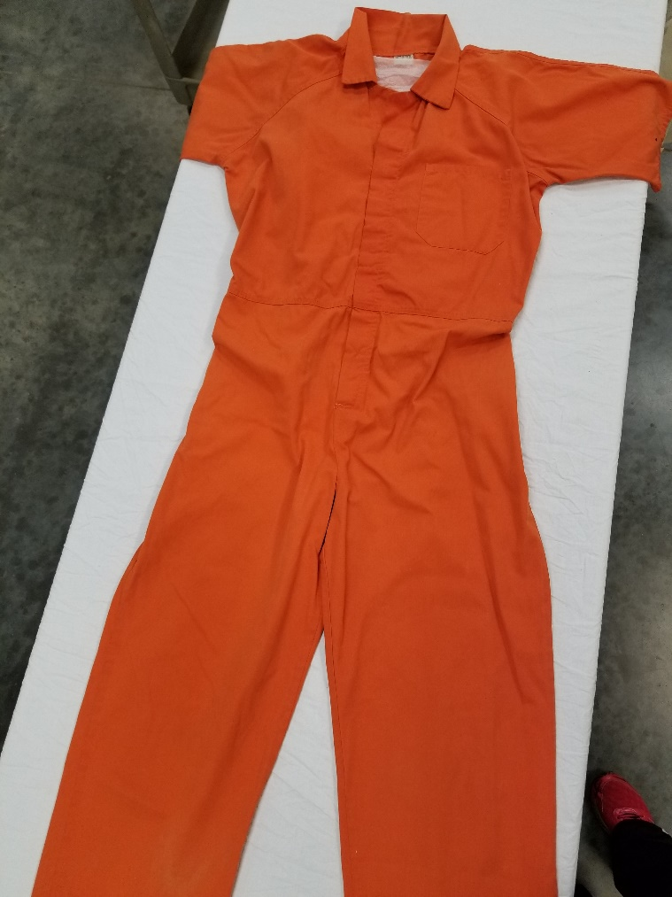

**Figure 2:** Detail of printing on the jumpsuit from *Cookie’s Fortune*; photograph by author

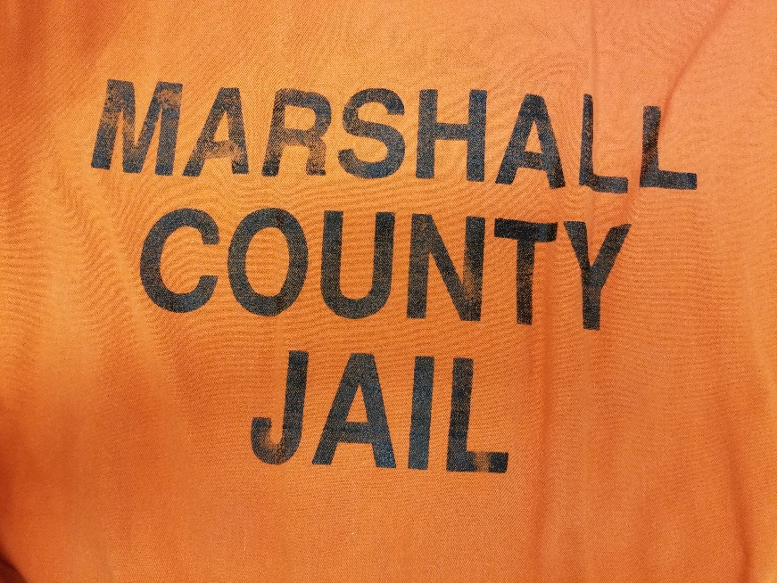

**Figure 3:** Tag on the jumpsuit from *Cookie’s Fortune*, showing that it was manufactured by Bob Barker (a major supplier of prison uniforms); photograph by author

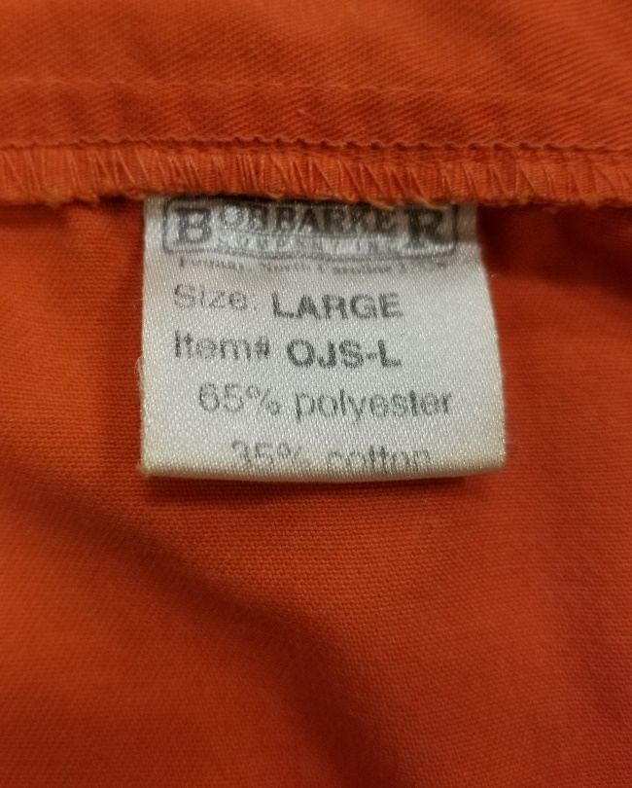

**Figure 4:** Shirt from a ‘chain gang’ prison uniform used in *O Brother Where Art Thou?* (2000); Elizabeth Sage Historic Costume Collection, photograph by author

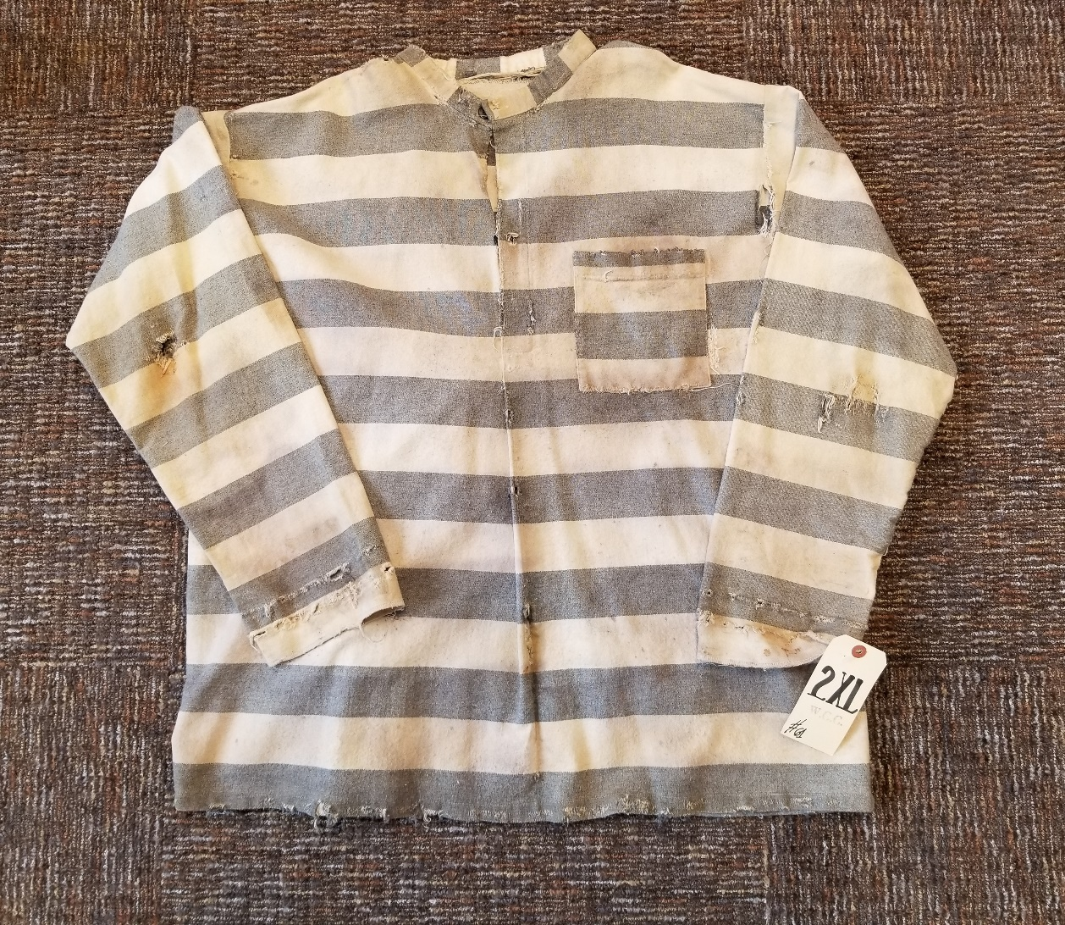

**Figure 5:** Detail of uniform used in *O Brother Where Art Thou?* showing heavy distressing around the collar; photograph by author

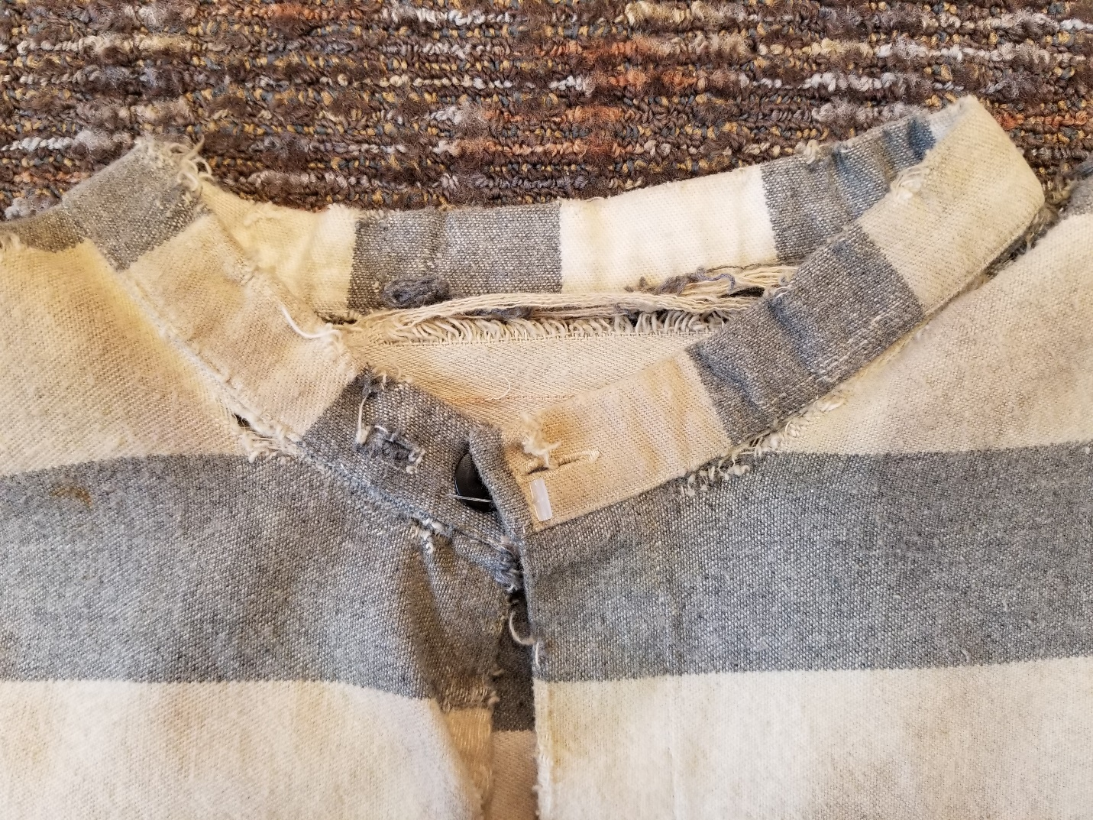

**Figure 6:** Photograph of ‘A Southern Chain Gang’ showing striped prison uniforms; taken by an unknown photographer for the Detroit Publishing Company (1900-1906), collection of the Library of Congress Prints and Photographs Division (LC-DIG-det-4a10700)

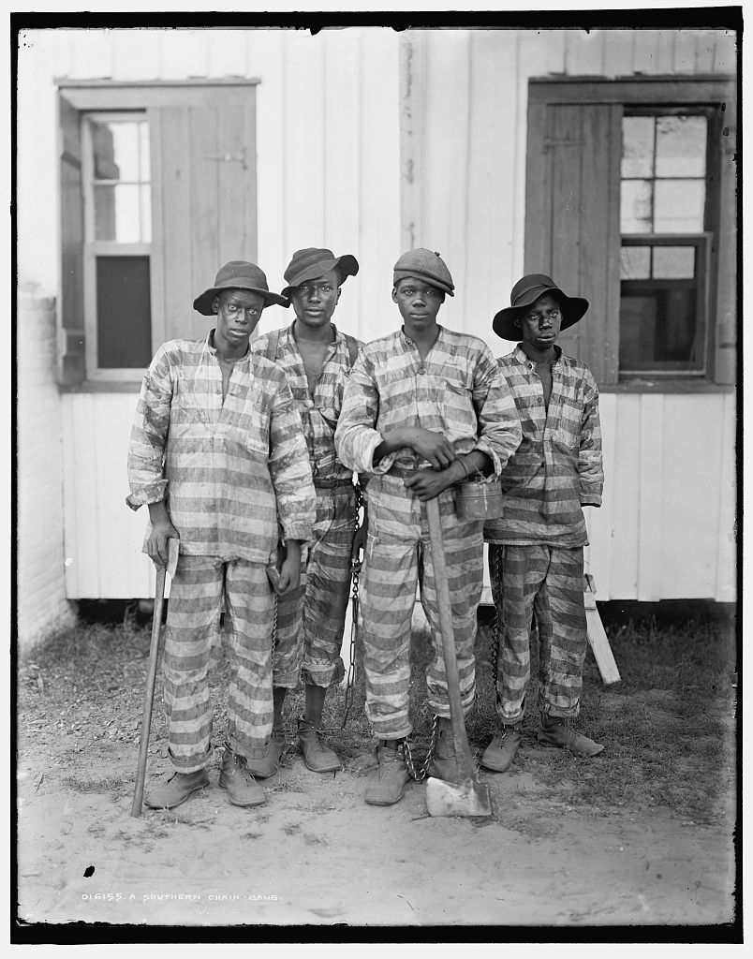

**Figure 7:** Prison Blues ‘yard coat’ made of heavy denim, sold by Correction Connection (a public-private partnership with the Oregon state prison system); collection of the author

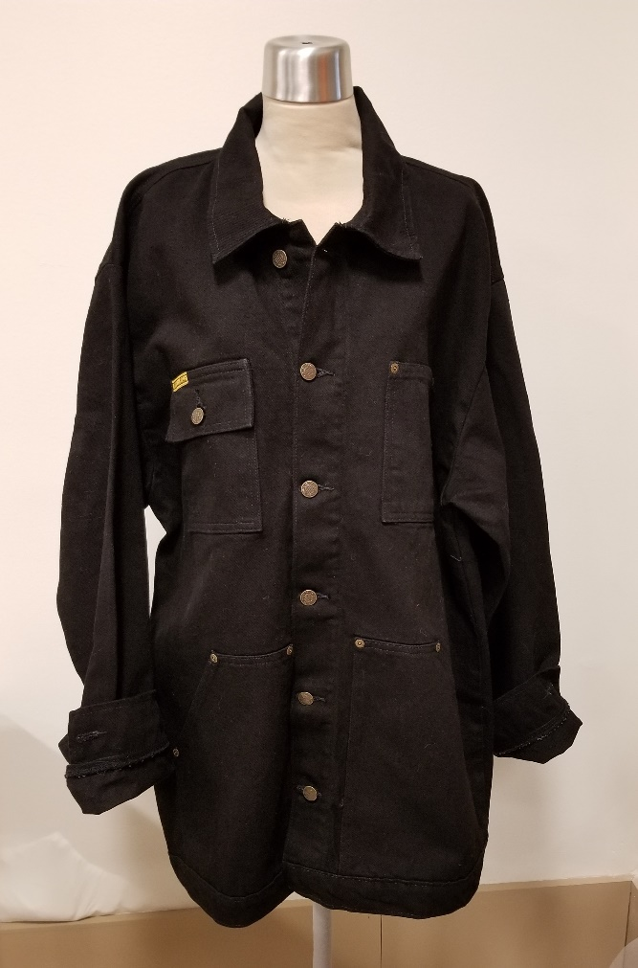

**Figure 8:** High-quality steel button on the Prison Blues yard coat

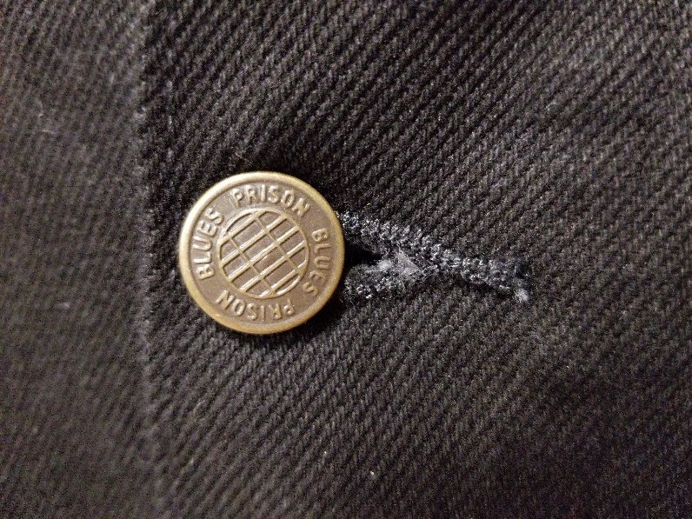

**Figure 9:** Packaging for a costume version of prison scrubs, similar to uniforms worn in *Orange in the New Black*; collection of the author

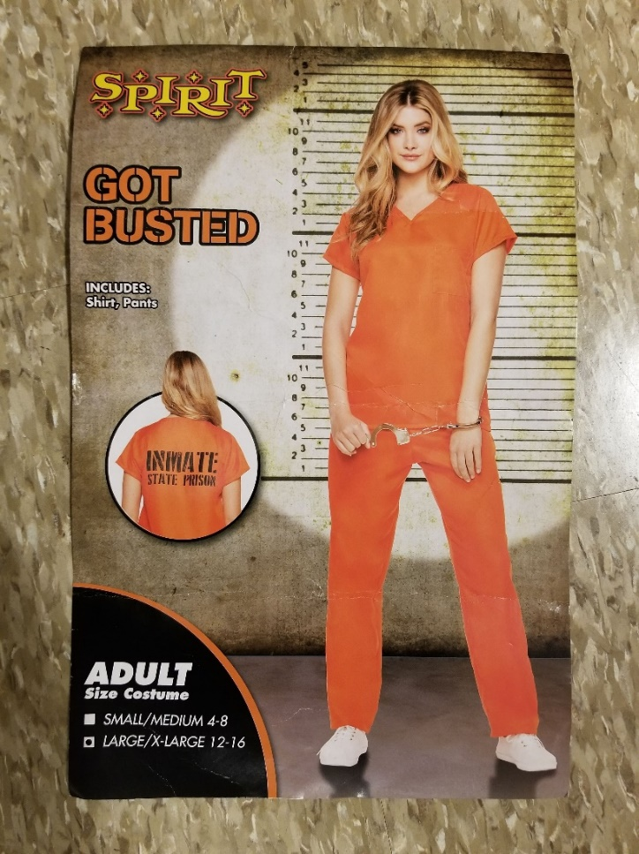

**Figure 10:** Sexy version of a prison jumpsuit—an orange mini dress with a handcuff belt, a generic prisoner number, and ‘BAD GIRL’ printed on the back; collection of the author

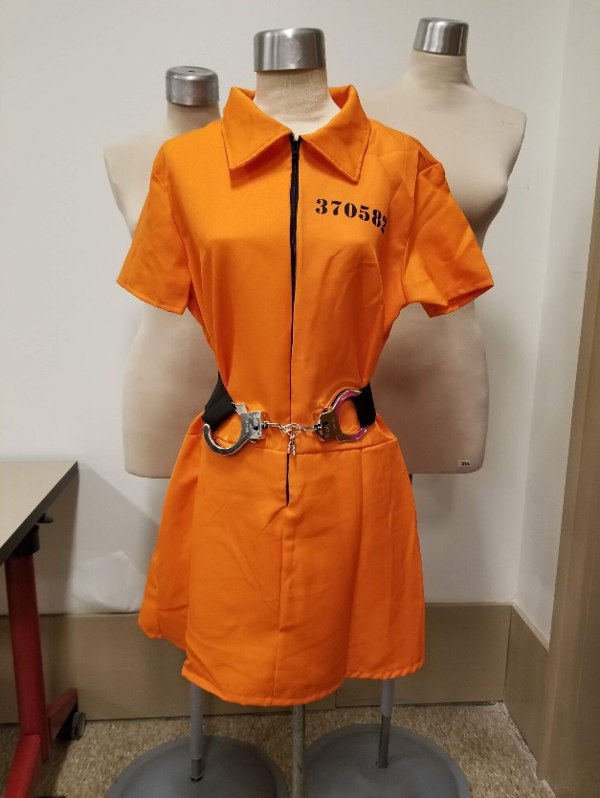

**Figure 11:** Packaging for ‘Miss Behaved’ costume mini dress, based on black-and-white striped prison uniforms; collection of the author

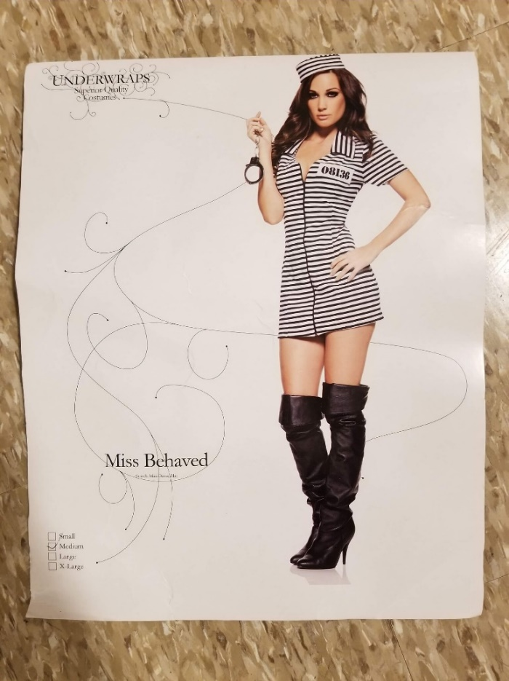

**Figure 12:** Packaging for a costume that blends a sexy version of a striped prison uniform with elements of late-Victorian dress, advertised by the seller as being ‘perfect for your bachelorette party;’ collection of the author

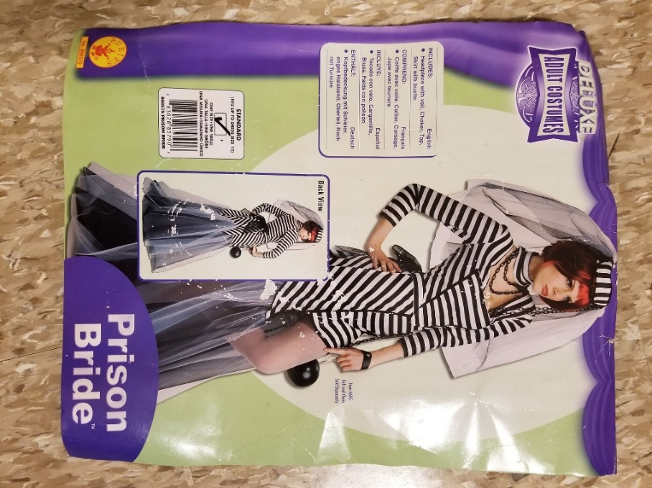

**Figure 13:** Packaging for an adult fantasy costume for men with black-and-white stripes and a generic prisoner number; collection of the author

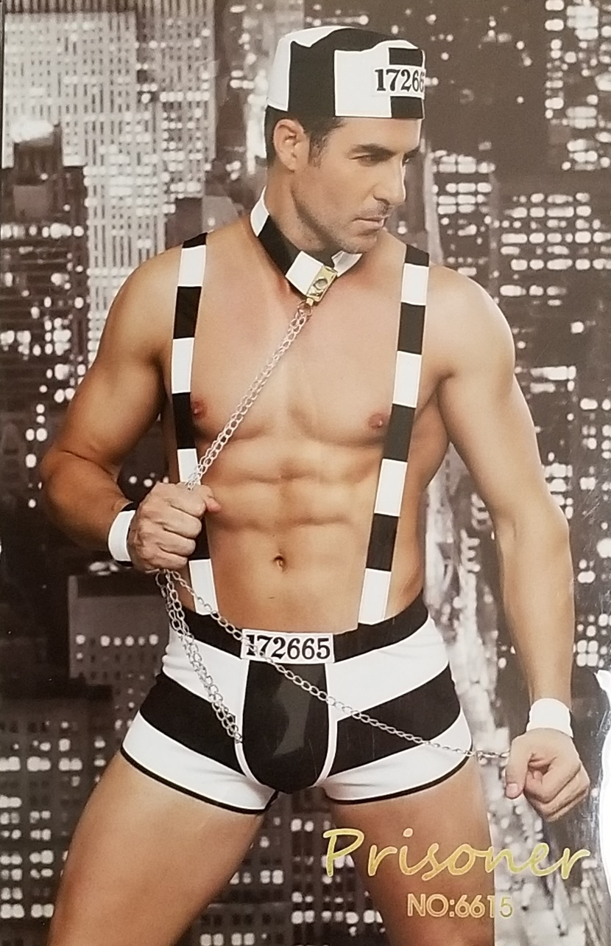

1. This figure accounts for the large number of pre-trial detainees in China, but may not account for all political prisoners, such as Uighurs being held in ‘re-education camps.’
2. This ‘Bob Barker’ is unrelated to the better-known, former host of *The Price is Right*.
3. Compared to the other 800+ pieces of clothing and accessories in the Glenn Close collection (now part of the Elizabeth Sage Historic Costume Collection at Indiana University), the prison uniform from *Cookie’s Fortune* is unusual in being highly-worn. While a few costumes (for example, for *Albert Nobbs*) have been distressed, most are in pristine condition.
4. All of these brands, for example, were worn by prisoners at Angola State Prison and are now represented among the prison uniforms held by the Smithsonian.